Project Title

TRAVEL GUIDE

Data Structures and Algorithms -3 (25CS2103E)
in

A.Y. 2026-2027

Submitted by

BANDI PRANAVI – 2520030026
CHARISHMA VIRODULA – 2520030140
YEMPARALA SATHWIKA – 2520030007

Team Number: 10
Section: 08

Under the guidance of

Faculty Name: Dr. V. Sireesha
Professor, Department of CSE

Hyderabad-500090, Telangana, India.

K L (Deemed to be) University
DEPARTMENT OF COMPUTER SCIENCE ENGINEERING



DECLARATION

The Mini Project Report entitled “Travel Guide – Travel Information Management System” is a record of bonafide work of BANDI PRANAVI – 2520030026, CHARISHMA VIRODULA – 2520030140, and YEMPARALA SATHWIKA – 2520030007, submitted in partial fulfillment for the course Data Structures and Algorithms - 3 (25CS2103E) at K L (Deemed to be) University.
The work presented in this report is based on the Travel Guide project materials and Java implementation supplied by the team. The report describes the implemented console-based Java features and the DSA technique used for destination search and spelling correction.

BANDI PRANAVI – 2520030026
CHARISHMA VIRODULA – 2520030140
YEMPARALA SATHWIKA – 2520030007

K L (Deemed to be) University
DEPARTMENT OF COMPUTER SCIENCE ENGINEERING
CERTIFICATE

This is to certify that the mini project based report entitled “Travel Guide – Travel Information Management System” is a bonafide work done and submitted by BANDI PRANAVI – 2520030026, CHARISHMA VIRODULA – 2520030140, and YEMPARALA SATHWIKA – 2520030007 in partial fulfillment of the requirements for the course Data Structures and Algorithms - 3 (25CS2103E), Department of Computer Science and Engineering, K L (Deemed to be) University, during the academic year 2026-2027.

Signature of the Supervisor

Signature of the HOD Signature of the External Examiner

ACKNOWLEDGEMENT

The successful completion of this project would not have been possible without the guidance, encouragement and support received from many people.
We express our sincere gratitude to our guide, Dr. V. Sireesha, Professor, Department of Computer Science and Engineering, for her valuable guidance, encouragement and support throughout the project.
We thank the Department of Computer Science and Engineering and the university for providing the academic environment and facilities required to complete this project.
We also thank our teaching and non-teaching staff, friends and classmates for their support and cooperation. Finally, we express our sincere gratitude to our parents for their continuous encouragement.

BANDI PRANAVI – 2520030026
CHARISHMA VIRODULA – 2520030140
YEMPARALA SATHWIKA – 2520030007

TABLE OF CONTENTS

S.No. | Contents | Page no.
1. | Abstract | 6
2. | Introduction | 7
3. | Literature survey | 8
4. | Problem Statement and Objectives | 9
5. | Hardware and Software requirements | 10
6. | Implementation | 11
7. | Results & Discussion | 16
8. | Conclusion & Future Scope | 19
9. | References | 20

1.ABSTRACT
Travelers often need quick and reliable information about tourist destinations, attractions, hotels, restaurants and transportation while planning or during their trips. Travel information is commonly distributed across different sources, which can make searching time-consuming and inconvenient.
The Travel Guide is designed as a searchable travel information system that stores and organizes important travel-related information in one centralized platform. The system allows users to search destinations and view useful information such as speciality, famous places, best time to visit, weather, travel precautions, things to carry and transportation.
Destination Search: Searches destinations by name.
Spelling Correction: Suggests a close destination when the entered name contains spelling errors.
Travel Information: Provides speciality, famous places, best months, weather and precautions.
Travel Packages: Provides Budget, Standard and Premium packages.
Booking Summary: Displays the selected destination, package, duration and price.
Emergency Information: Displays police, ambulance and fire emergency numbers.
Search Efficiency: Uses Dynamic Programming based Edit Distance for closest-destination suggestions.
The supplied project materials also identify centralized information, faster retrieval, easy destination searching and improved travel planning as expected outcomes.
Team Name: Team 10
Team Members:
BANDI PRANAVI – 2520030026
CHARISHMA VIRODULA – 2520030140
YEMPARALA SATHWIKA – 2520030007

- INTRODUCTION

Planning a trip requires information about destinations, attractions, suitable travel periods, weather, transportation, safety precautions and available packages. When this information is scattered across multiple sources, users may spend more time comparing and locating the information they need.

The Travel Guide project provides a centralized console-based Java application for organizing basic travel information. The program maintains destination information in arrays and provides menu-driven access to destination search and details.

Major Information Provided
- Destination name and speciality
- Famous tourist places
- Best time to visit
- Weather information
- Travel precautions
- Things to carry
- Transportation options
- Travel packages and prices
- Booking summary
- Emergency information

User Flow
- Launch the Travel Guide.
- Enter any non-empty username and password.
- Open the main menu.
- Search for a destination or view all destinations.
- If the destination is misspelled, receive a close-match suggestion.
- Open destination details and select the required information.
- View travel packages and confirm a booking if required.

- LITERATURE SURVEY
Existing travel-information systems commonly organize information by destinations, categories and locations. The supplied project abstract identifies the need for a centralized repository because tourists otherwise search across multiple sources for attractions, hotels, restaurants and transportation.

Existing Approach | Limitation | Approach in Travel Guide
Scattered travel information | Information is distributed across different sources | Centralized destination information
Exact destination search | Spelling errors can prevent a direct match | Closest-destination suggestion using Edit Distance
Manual comparison of travel options | Users spend time comparing information | Structured destination details and packages
Separate safety information | Precautions may be difficult to locate quickly | Travel precautions and emergency information in the destination menu
Basic destination lists | Lists alone do not provide context | Destination-specific speciality, places, weather and transport
Research Gap
- Travel information can be difficult to access when it is scattered across sources.
- Exact matching does not handle misspelled destination names.
- Users benefit from combining destination search with organized travel details.
- A DSA-based search component can improve the handling of spelling variation.

- Problem Statement and Objectives
Problem Statement
Travel information is scattered across different sources, making it time-consuming for tourists to find attractions, suitable hotels or restaurants, transportation information and other travel details. The system should provide quick and organized access to travel information through a centralized searchable platform.
Objectives
- Provide a centralized travel information system.
- Allow users to search destinations quickly.
- Provide organized information about attractions and important places.
- Provide best time to visit and weather information.
- Provide travel precautions and things to carry.
- Provide transportation information.
- Handle destination spelling mistakes through Edit Distance.
- Provide travel packages with duration and price.
- Generate a booking summary after package selection.
- Provide emergency contact information.
- Demonstrate the application of Dynamic Programming to a real-world travel search problem.
Scope
The supplied implementation focuses on a console-based Java Travel Guide with ten predefined destinations and menu-driven travel information. The supplied PPT/abstract also identify future extensions such as AI recommendations, itinerary generation, GPS/maps, real-time transport, weather integration, mobile application, voice search and multilingual support.

- HARDWARE AND SOFTWARE REQUIREMENTS
Hardware Requirements:
- Processor: Intel Core i5 / equivalent or above
- RAM: 8 GB or above
- Storage: 256 GB or above
- Display: Standard monitor
- Internet: Not required for core system execution
Software Requirements:
- Operating System: Windows / Linux
- Programming Language: Java
- IDE: VS Code / IntelliJ IDEA / Eclipse
- JDK: Java JDK 8 or above
- Algorithms: Naive String Matching, KMP, Rabin-Karp, Levenshtein Distance (Dynamic Programming), Edmonds-Karp Maximum Flow
- Database: Patient and medical data are generated/stored within the Java application
- Visualization/Output: DP Matrix, Search Results, Benchmark Results and Maximum-Flow Network Output
- IMPLEMENTATION
HealthQuery Engine is implemented in Java and is organised into four modules. The complete source code of each module is given below.
Module 1: Destination Search (DestinationSearch.java)
This module stores the available travel destinations and performs destination searching using arrays and linear search. It also displays destination-related information such as speciality, famous places, best time to visit, weather, transportation and safety precautions.

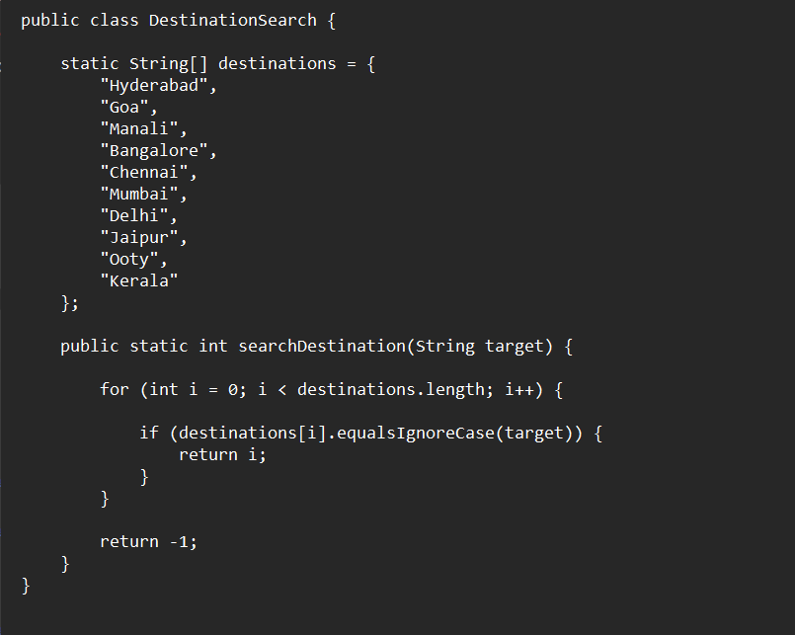

Module 2: Spelling Correction (SpellingCorrector.java)
This module implements Levenshtein Edit Distance using Dynamic Programming. It compares the entered destination with available destinations and suggests the closest destination when the user enters a spelling mistake.

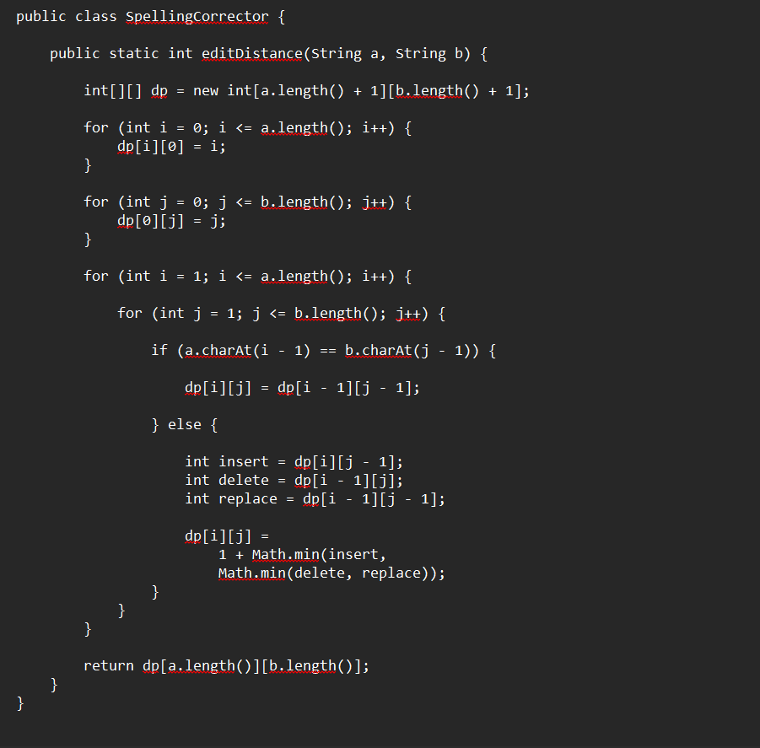

Module 3: String Matching (StringMatcher.java)
This module implements string searching algorithms such as KMP and Rabin-Karp to search keywords inside destination descriptions.
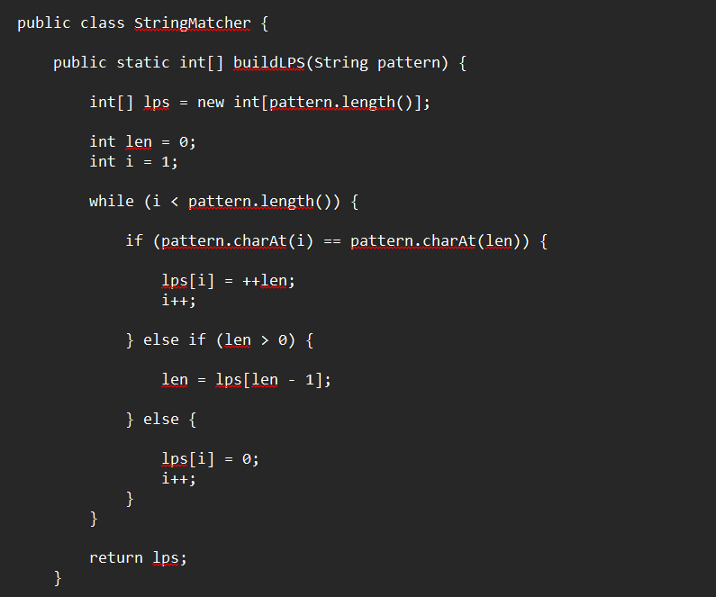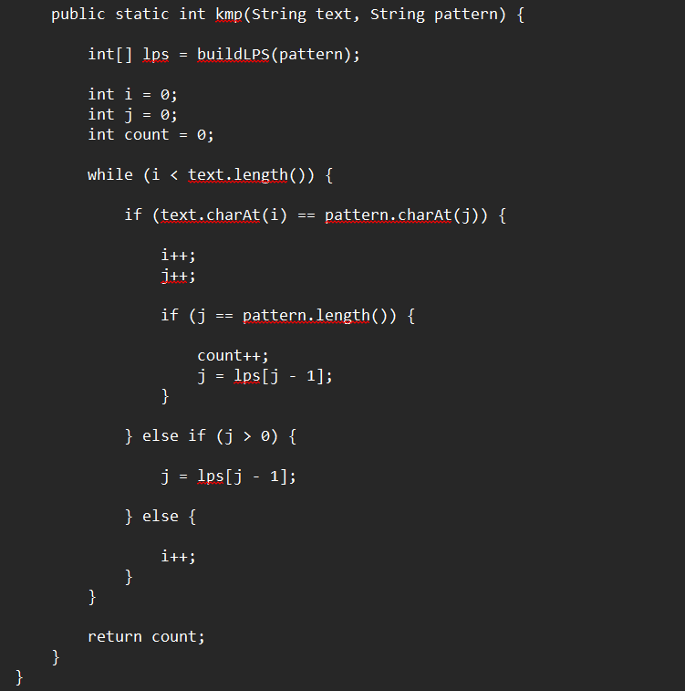
Module 4: Travel Packages (TravelPackages.java)
This module manages the different travel packages such as Budget, Standard and Premium. It calculates the total package cost based on the number of persons.
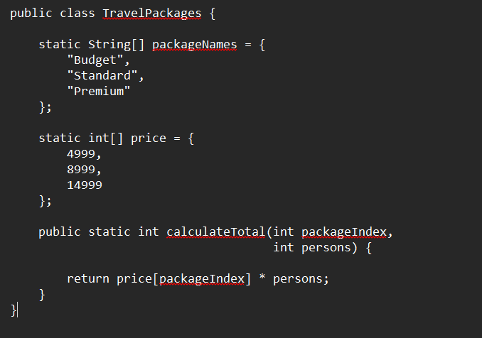
Module 5: Itinerary Optimization (ItineraryDP.java)
This module demonstrates Dynamic Programming on subsets / Bitmask DP to select a suitable combination of tourist places while considering the selected places.
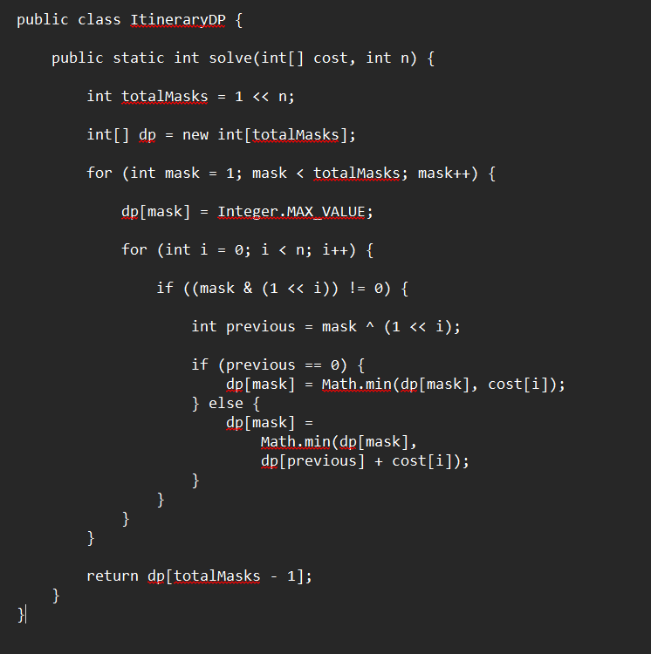
Module 6: Payment and Quotation (Booking.java)
This module handles package booking, payment selection and quotation generation. It calculates package amount, service tax, discount and final payable amount.

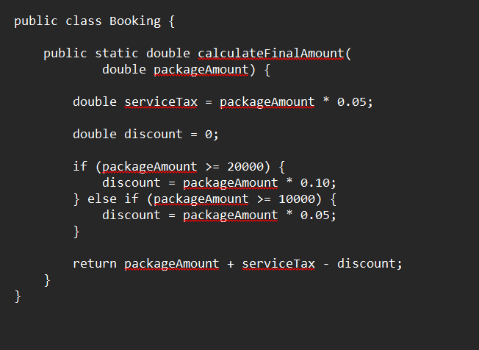

RESULTS & DISCUSSION
The Travel Guide application was implemented and tested using Java. The results summarize the performance of destination search, spelling correction, destination information retrieval, package selection, payment processing, and quotation generation. The screenshots that follow demonstrate the output of each major feature.
Metric | Result
Exact destination search | Destination found successfully
Spelling correction | Incorrect destination corrected using Edit Distance
Edit distance "Manli" → "Manali" | Closest destination identified
Destination information | Speciality, places, weather and precautions displayed
Package selection | Budget, Standard and Premium packages displayed
Package cost calculation | Total calculated based on number of persons
Payment processing | Payment completed successfully in demo mode
Quotation generation | Booking quotation generated successfully

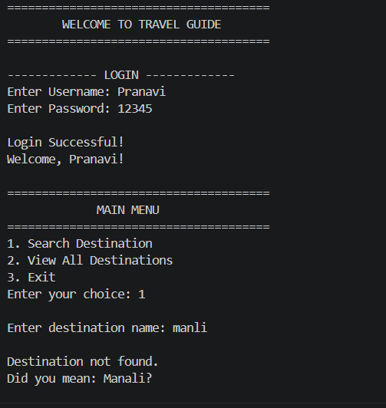
Figure 1: Destination search and destination information menu

The exact search for "diabetes" returns two patients. For the misspelled query "diabtes" exact search finds nothing, but fuzzy search (edit distance ≤ 2) still retrieves the same two patients.
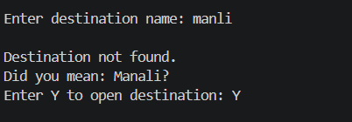
Figure 2: Spelling correction using Edit Distance
When the user enters a destination with a spelling mistake, the system calculates the edit distance between the entered word and available destinations. The destination with the minimum distance is suggested to the user.
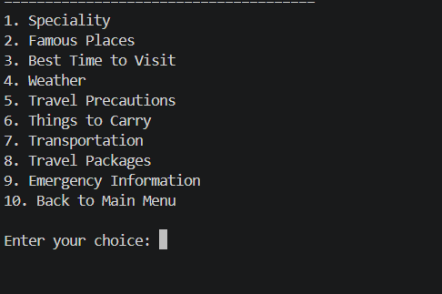
Figure 3: Destination information displayed by the Travel Guide

The system provides important destination information including speciality, famous places, best time to visit, weather conditions, safety precautions, things to carry and transportation options.
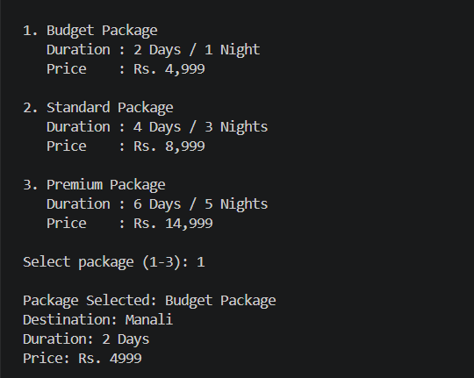
Figure 4: Travel package selection and cost calculation
The application provides three travel packages. The total package cost is calculated according to the selected package and number of persons.

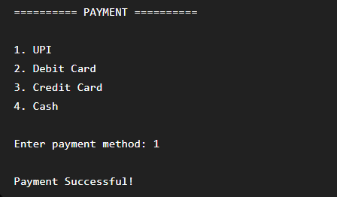
Figure 5: Demo payment processing
The user can select a payment method from the available options. The payment feature is implemented as a demonstration and does not process real financial transactions.

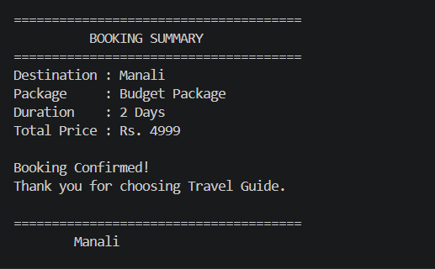
Figure 6: Final booking quotation and confirmation
After successful package selection and payment, the system generates a quotation containing the booking ID, destination, package details, number of persons, package amount, service tax, discount, final amount, payment status and booking status.
Discussion
The result demonstrates that the system combines organized travel information with a DSA-based spelling correction mechanism. The user does not need to know the internal algorithm; the application uses it to improve destination search.

- CONCLUSION & FUTURE SCOPE
Conclusion
The Travel Guide project provides a simple and practical travel information management system. It organizes destination-related information such as speciality, famous places, best visiting period, weather, precautions, things to carry and transportation in a centralized application.
The project also demonstrates the application of Data Structures and Algorithms through Levenshtein Edit Distance implemented with Dynamic Programming. This technique helps the system suggest a close destination when a user enters an incorrect spelling. The package and booking modules further demonstrate how the organized information can support basic travel planning.
Future Scope
- AI-based travel recommendations
- Personalized itinerary generation
- Map and GPS integration
- Real-time transportation information
- Weather information integration
- Mobile application
- Voice-based travel search
- Multi-language support
These enhancements are listed in the supplied project materials and can extend the system from a basic centralized information repository into a more intelligent travel planning platform.

- REFERENCES
[1] T. H. Cormen, C. E. Leiserson, R. L. Rivest and C. Stein, Introduction to Algorithms, 4th ed., MIT Press, 2022.
[2] R. Sedgewick and K. Wayne, Algorithms, 4th ed., Addison-Wesley, 2011.
[3] V. I. Levenshtein, “Binary codes capable of correcting deletions, insertions and reversals,” Soviet Physics Doklady, vol. 10, no. 8, 1966.
[4] Oracle Corporation, Java Platform, Standard Edition Documentation.
[5] Travel Guide – Travel Information Management System, project abstract supplied for DSA-3 (25CS2103E), A.Y. 2026-2027.
[6] Travel Guide – DSA-3 project presentation supplied by the project team.
[7] TravelGuide.java, source code supplied by the project team.

